PROJECT TITLE

A

MAJOR PROJECT REPORT

*Submitted in partial fulfillment of the requirements*

*for the award of the degree of*

BACHALOR OF TECHNOLOGY

In

Computer Science & Engineering

Submitted to



RAJIV GANDHI PROUDYOGIKI VISHWAVIDYALAYA,

BHOPAL (M.P.)



Department of Computer Science Engineering

Sri Aurobindo Institute of Technology, Indore (M.P.)

**2023-2024**

SCHOOLITE



The Major Project-I report submitted to

Rajiv Gandhi Proudyogiki Vishwavidyalaya, Bhopal

towards partial fulfillment of the Degree of

Bachelor of Technology

in

Computer Science & Engineering

Guided by Submitted by

Sudha Sharma Sharddha Shaiv

Assistant Proffessor Himanshu Sharma

Department of Computer Science Engineering

Sri Aurobindo Institute of Technology,Indore(M.P.)

**2023-2024**

**SRI AUROBINDO Institute of Technology, INDORE**



**Recommendation**

This is to certify that Ms Shraddha Shaiv(0873CS201092) student of B.Tech. VII Semester in the year 2023-24 of Computer Science Engineering Department of this institute has completed his/her/their work on “*SCHOOLITE*” for Major Project-I based on syllabus and has submitted a satisfactory account of his/her/their work in this report which is recommended for the partial fulfillment of the degree of Bachelor of Engineering in Computer Science.

## 

## **Project Guide, Sudha Sharma HoD, Sunil Parihar**

CSE Department CSEDepartment

SAIT Indore SAIT Indore

### **Director,**

**SAIT Indore**

**SRI AUROBINDO Institute of Technology, INDORE**



**Certificate**

This is to certify that the work embodied in this project entitled “*Schoolite*” being submitted by Mr. Shraddha Shaiv(0873CS201036), student of B.Tech. VII semester, Computer Science Engineering department in the year 2023-24, is a satisfactory account of his/her/their work based on syllabus which is accepted in partial fulfillment of degree of Bachelor of Engineering in Computer Science .

**Internal Examiner External Examiner**

**Date Date**

**SRI AUROBINDO Institute of Technology, INDORE**



**Declaration**

We hereby declare that the Project entitled “Schoolite" is our own work conducted under the supervision of Sudha Sharma, Designation, Department of Computer Science & Engineering at Sri Aurobindo Institute of Technology, Indore, M.P.

We further declare that to the best of our knowledge this report does not contain any part of work that has been submitted for the award of any degree either in this institute or in other institute without proper citation.

Shraddha Shaiv 0873CS201092

Himanshu Sharma 0873CS201036

**Acknowledgement**

We express deep gratitude for enthusiasm and valuable suggestions that we got from our guide **SUDHA SHARMA** for successful completion of the project. This project was not possible without the invaluable guidance of our project guide.

We are also thankful to our project coordinator **Sudha Sharma,** for his/her technical guidance, encouragement and support.

We are deeply indebted to **Sunil Parihar**, Head Department of Computer Science and Engineering, for providing us support and resources for successful completion of this project.

I would like to give thanks to **Durgesh Mishra** for their valuable guidance and motivation for the completion of the work.

Finally, we are thankful to all the people who are related to the project directly or indirectly.

Shraddha Shaiv 0873CS201092

Himanshu Sharma 0873CS201036

**REPORT FORMAT**

**CS-VII Semester jUL-dEC 2023**

**Date: 03-10-2023**

**FRONT PAGE**

**RECOMMENDATION II**

**CERTIFICATE III**

**DECLARATION IV**

**ACKNOWLEDGEMENT V**

**ABSTRACT VI**

**TABLE OF CONTENTS VII**

**TABLE INDEX VIII**

**FIGURE INDEX IX**

**List of Symbols, Abbreviations and Nomenclature X**

1. **INTRODUCTION**
   1. **Introduction to current system**
   2. **Need of *proposed* system**
   3. **Objectives**
2. **SYSTEM DEVELOPMENT LIFE CYCLE**
3. **ANALYSIS**
   1. **Requirement analysis**
   2. **Requirement Specification**
   3. **Usecase Analysis** 
      1. **Usecase diagram**
      2. **Usecase description**
      3. **Activity diagram**
4. **DESIGN**
   1. **System Flow Diagram**
   2. **Data Flow Diagram**
   3. **Modules identified**
   4. **Sequence Diagrams**
   5. **Class Diagram** 
      1. **Database Design**
5. **E-R Diagram**
6. **IMPLEMENTATION**
   1. **Platform Used**
      1. **Hardware Platform**
      2. **Software Platform**
   2. **Implementation Level Details**
   3. **Testing** 
      1. ***Testing Technique* used**
7. **CONCLUSION**
   1. **Important Features**
   2. **Limitation**
   3. **Future Work**
8. **REFERENCES**

**Introduction to current system**

This project is a actually a web based school student requirement shop for their school & education related needs. In this website we have our city top-10 school list in which provide their uniform , syllabus kit , stationery , worksheet or any other requirement related to this schools.

This project is an attempt to provide the advantages of shop all the student need material related to this schools or any other education related benefits . It helps buying the products in the shop using internet . Thus the customer will

get the service of online shopping and home delivery .

**Need of *proposed* system**

The objective of the project is to make website to purchase items related to school. In order to build such an website that support any browser need to be provided. complete and efficient web which can provide the online student material shopping experience is the basic objective of the project.

**Scope**

In the scope , we can say that it can be expand from top-10 city level school to all over city level . 1 more scope is that further colleges can also be added in the future.so that in this expansion providing facilities can also be increased .

**Problem in existing system**

The current system for student uniform shopping is to visit the shop manually and from the available product choose the item customer want and buying the item by payment of the price of the item .

* It is less user-friendly.
* User must go to shop and select products.
* It is difficult to identify the required product. Description of the product limited.
* It is a time-consuming process Not in reach of distant users.

**Statement of Problem**

In the proposed system customer need not go to the shop for buying the products. The can order the product he wish to buy through the his Smartphone or any other devices . The system also recommends a home delivery system for the purchased products.

**System Requirement Analysis**

**SOFTWARE REQUIREMENT –**

Supports any search engine or browser like google chrome , Microsoft edge , firefox etc.

**IMPLEMENTTION REQUIREMENT -**

* **SOFTWARE PLATEFORM –**
* **Web Development**: For the web-based platform, using technologies such as HTML, CSS, JavaScript for front-end development.
* **Backend Development**: Consider using language Node.js for server-side scripting. Framework Express.js can help in creating robust and scalable back-end systems.
* **Database Management**: Database technology MongoDB could be used for storing and managing data efficiently

**USER**

**USER LOGIN**

Description of feature

This feature used by the user to login into system. user must login with his user name and password to the system after registration. If they are invalid, the user not allowed to enter the system.

Functional requirement

* Username and password will be provided after user registration is confirmed.
* Password should be hidden from others while typing it in the field

**REGISTER NEW USER**

Description of feature

new user will have to register in the system by providing essential details in order to view the products in the system. The admin must accept a new user by unblocking him.

Functional requirement

System must be able to verify and validate information.

The system must encrypt the password of the customer to provide security.

**PURCHASING ITEM**

Description of feature

The user can add the desired product into his cart by clicking add to cart option on the product. They can view his cart by clicking on the cart button. All products added by cart can be viewed in the cart. User can remove an item from the cart by clicking remove. After confirming the items in the cart the user can submit the cart by providing a delivery address. On successful submitting the cart will become empty.

Functional requirement

System must ensure that, only a registered customer can purchase items.

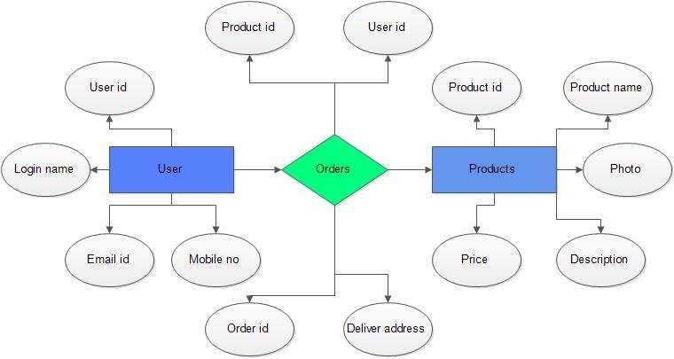**E-R DIAGRAMS**

**DATA FLOW DIAGRAM**

**Context level DFD – 0 level**

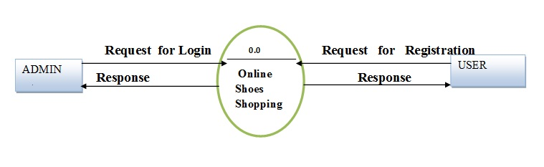

**1st Level Admin  Side DFD**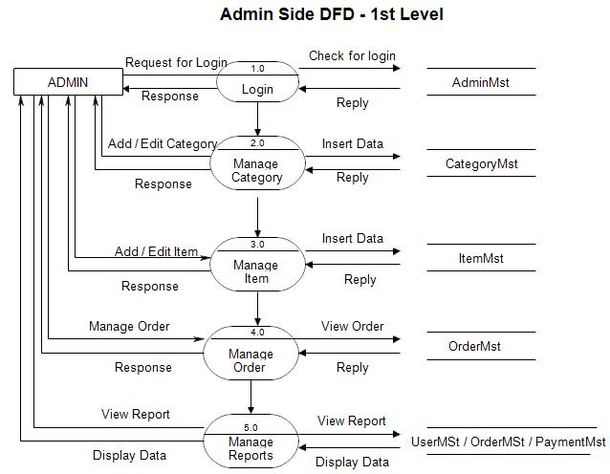

**2nd Level – Admin side DFD**

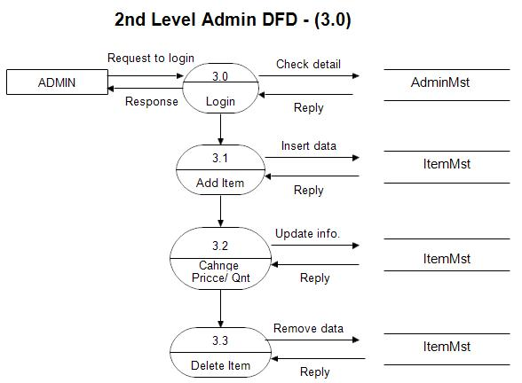

**1st level – User side Data flow Diagram**

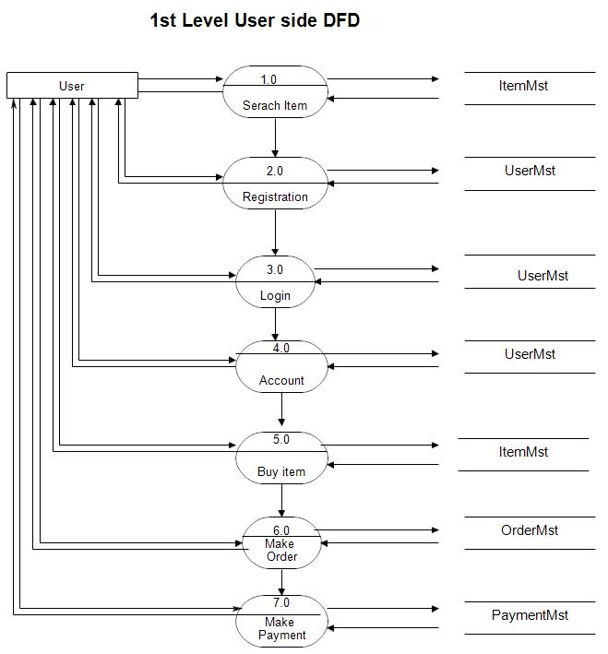

**2nd level – User side DFD**

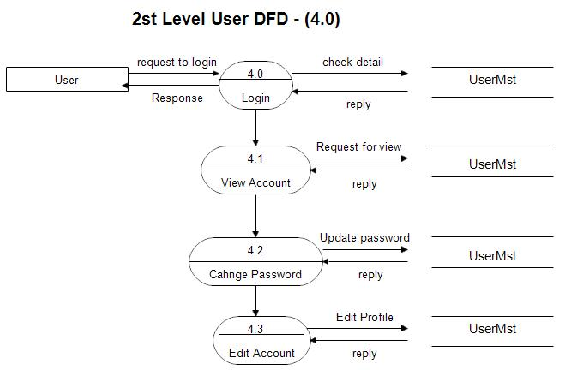

**SYSTEM Dia -**



**Class diag -**

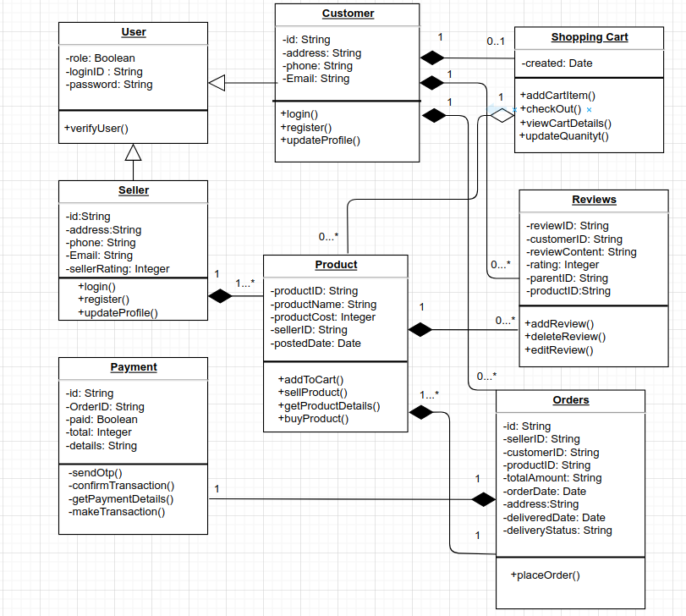

**USE CASE –**

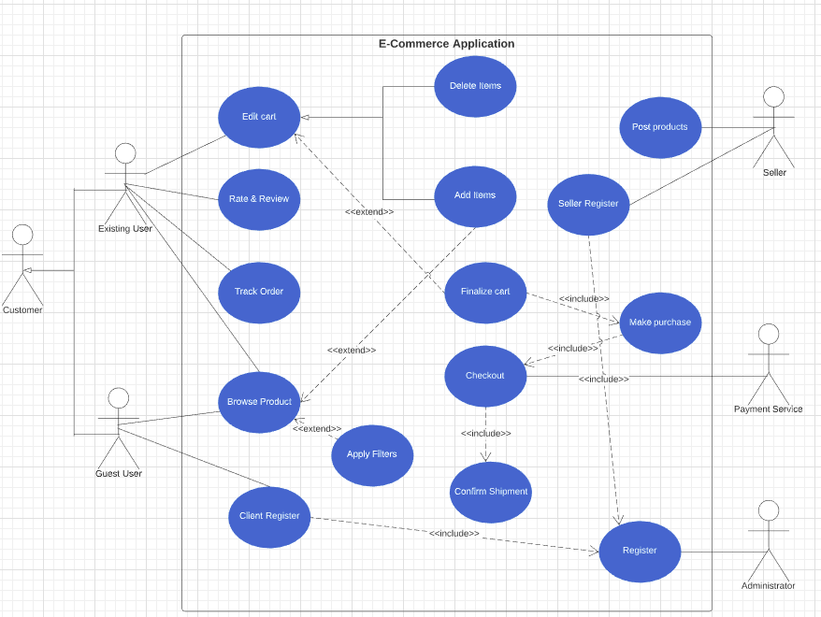

Activity Dia –

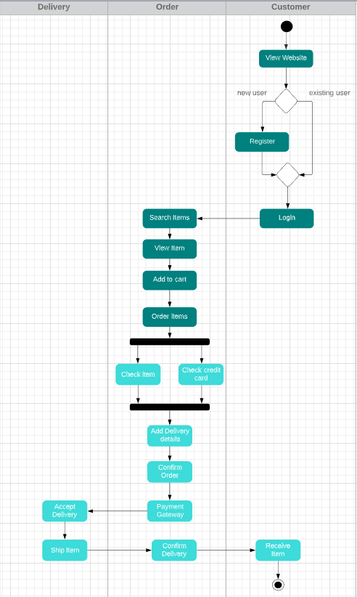

**CONCLUSION**

The project entitled **Schoolite** was completed successfully.

The system has been developed with much care and free of errors and at the same time it is efficient and less time consuming. The purpose of this project was to develop a web-site and for purchasing items from a site.

This project helped us in gaining valuable information and practical knowledge on several topics like designing web pages using html & CSS , usage of responsive templates , Backend with express & MongoDB . The entire system is secured. Also the project helped us understanding about the development phases of a project and software development life cycle. We learned how to test different features of a project.

This project has given us great satisfaction in having designed a complete website which can be implemented .

There is a scope for further development in our project to a great extent . A number of features can be added to this system in future like providing.

**Bibliography and Reference :**

1. W3Schools. (2021). "HTML Tutorial." Retrieved from <https://www.w3schools.com/html/>
2. CSS-Tricks. (2021). "CSS Tutorial." Retrieved from <https://css-tricks.com/>
3. Mozilla Developer Network. (2021). "JavaScript Guide." Retrieved from <https://developer.mozilla.org/en-US/docs/Web/JavaScript/Guide>
4. Oracle. (2021). "Java Server Pages (JSP) Documentation." Retrieved from <https://docs.oracle.com/javaee/7/tutorial/jsf-convert.htm>
5. Node.js. (2021). "Node.js Documentation." Retrieved from <https://nodejs.org/en/docs/>
6. MongoDB. (2021). "MongoDB Documentation." Retrieved from <https://docs.mongodb.com/>